**Question**

Implement SVM and compare it with all the other models using the following datasets:  
1. Diabetes

2. Vertebral

**Source Code**

**Diabetes Dataset**

import pandas as pd

from sklearn.model_selection import train_test_split

from sklearn.preprocessing import StandardScaler

from sklearn.tree import DecisionTreeClassifier

from sklearn.neighbors import KNeighborsClassifier

from sklearn.linear_model import SGDClassifier

from sklearn.naive_bayes import GaussianNB

from sklearn.svm import SVC

from sklearn.metrics import accuracy_score, precision_score, recall_score, f1_score

data = pd.read_csv('dataset/diabetes.csv')

y = data.iloc[:, -1]

X = data.iloc[:, :-1]

X_train, X_test, y_train, y_test = train_test_split(X, y, test_size=0.2, random_state=42)

scaler = StandardScaler()

X_train_scaled = scaler.fit_transform(X_train)

X_test_scaled = scaler.transform(X_test)

def decision_tree():

model = DecisionTreeClassifier()

model.fit(X_train, y_train)

y_pred = model.predict(X_test)

return y_pred

def kNN_classifier():

model = KNeighborsClassifier(n_neighbors=5)

model.fit(X_train, y_train)

y_pred = model.predict(X_test)

return y_pred

def mini_batch_gradient_descent():

model = SGDClassifier(loss='log_loss', max_iter=1000, tol=1e-3)

model.fit(X_train, y_train)

y_pred = model.predict(X_test)

return y_pred

def naive_bayes_classifier():

model = GaussianNB()

model.fit(X_train, y_train)

y_pred = model.predict(X_test)

return y_pred

def svm():

svm_model = SVC(kernel='linear', random_state=42)

svm_model.fit(X_train, y_train)

y_pred = svm_model.predict(X_test)

return y_pred

def evaluate(y_pred, model):

accuracy = accuracy_score(y_test, y_pred)

precision = precision_score(y_test, y_pred, average='binary')

recall = recall_score(y_test, y_pred, average='binary')

f1 = f1_score(y_test, y_pred, average='binary')

print(f'Model: {model}')

print(f'Accuracy: {accuracy:.4f}')

print(f'Precision: {precision:.4f}')

print(f'Recall: {recall:.4f}')

print(f'F1 Score: {f1:.4f}')

print()

def main():

y_pred = decision_tree()

evaluate(y_pred, 'Decision Tree')

y_pred = kNN_classifier()

evaluate(y_pred, 'kNN Classifier')

y_pred = mini_batch_gradient_descent()

evaluate(y_pred, 'Mini-Batch Gradient Descent')

y_pred = naive_bayes_classifier()

evaluate(y_pred, 'Naive Bayes Classifier')

y_pred = svm()

evaluate(y_pred, 'Support Vector Machine')

if __name__ == '__main__':

main()

**Output**

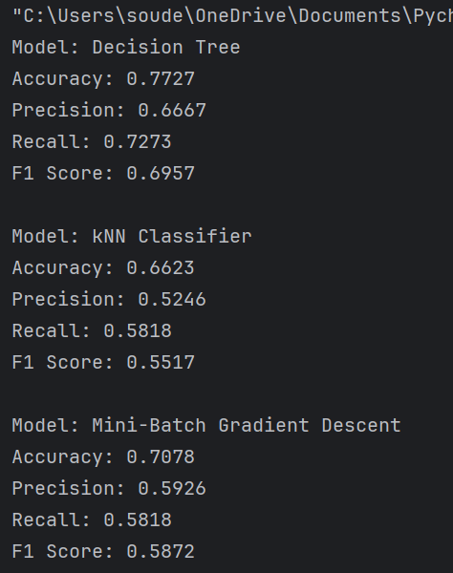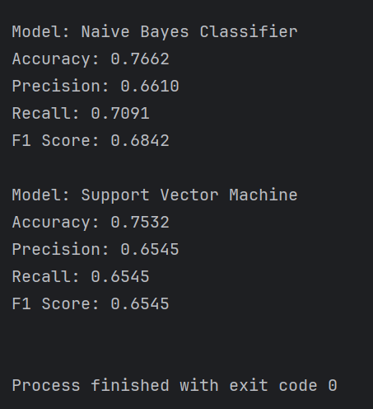*Terminal*

**Vertebral Dataset**

import pandas as pd

from sklearn.linear_model import SGDClassifier

from sklearn.model_selection import train_test_split

from sklearn.naive_bayes import GaussianNB

from sklearn.neighbors import KNeighborsClassifier

from sklearn.preprocessing import LabelEncoder

from sklearn.svm import SVC

from sklearn.tree import DecisionTreeClassifier

from sklearn.metrics import accuracy_score, precision_score, recall_score, f1_score

df = pd.read_csv('dataset/vertebral.csv')

X = df.drop('class', axis=1)

y = df['class']

le = LabelEncoder()

y = le.fit_transform(y)

X_train, X_test, y_train, y_test = train_test_split(X, y, test_size=0.2, random_state=42, stratify=y)

def decision_tree():

model = DecisionTreeClassifier()

model.fit(X_train, y_train)

y_pred = model.predict(X_test)

return y_pred

def kNN_classifier():

model = KNeighborsClassifier(n_neighbors=5)

model.fit(X_train, y_train)

y_pred = model.predict(X_test)

return y_pred

def mini_batch_gradient_descent():

model = SGDClassifier(loss='log_loss', max_iter=1000, tol=1e-3)

model.fit(X_train, y_train)

y_pred = model.predict(X_test)

return y_pred

def naive_bayes_classifier():

model = GaussianNB()

model.fit(X_train, y_train)

y_pred = model.predict(X_test)

return y_pred

def svm():

svm_model = SVC(kernel='linear', random_state=42)

svm_model.fit(X_train, y_train)

y_pred = svm_model.predict(X_test)

return y_pred

def evaluate(y_pred, model):

accuracy = accuracy_score(y_test, y_pred)

precision = precision_score(y_test, y_pred)

recall = recall_score(y_test, y_pred)

f1 = f1_score(y_test, y_pred)

print(f"Model: {model}")

print(f"Accuracy: {accuracy:.4f}")

print(f"Precision: {precision:.4f}")

print(f"Recall: {recall:.4f}")

print(f"F1 Score: {f1:.4f}")

print()

def main():

y_pred = decision_tree()

evaluate(y_pred, 'Decision Tree')

y_pred = kNN_classifier()

evaluate(y_pred, 'kNN Classifier')

y_pred = mini_batch_gradient_descent()

evaluate(y_pred, 'Mini-Batch Gradient Descent')

y_pred = naive_bayes_classifier()

evaluate(y_pred, 'Naive Bayes Classifier')

y_pred = svm()

evaluate(y_pred, 'Support Vector Machine')

print("Class mapping:", dict(zip(le.classes_, le.transform(le.classes_))))

if __name__ == '__main__':

main()

**Output**

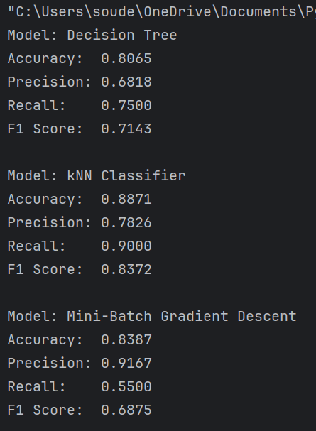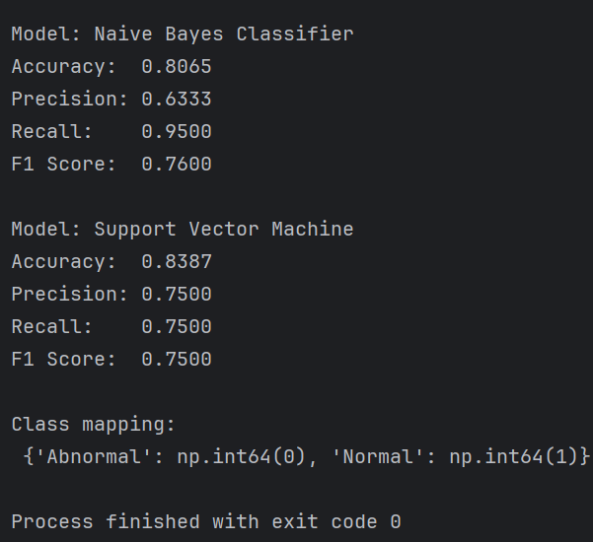*Terminal*

**Comparison**

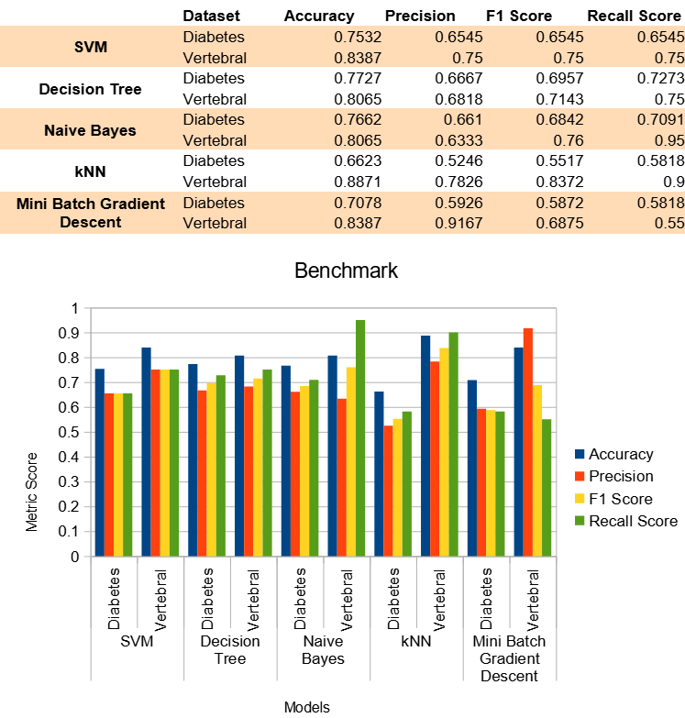*Visualization*